

NAME: EXCELLENCE NG’ENDO
ADM NO: BSCCS/2024/53679

COURSE: BACHELOR OF SCIENCE IN COMPUTER SCIENCE
DEPARTMENT: COMPUTING AND INFORMATICS.
UNIT NAME: ADVANCED WEB DESIGN AND DEVELOPMENT
UNIT CODE:BIT3208
Lecturer Name- MICHAEL NYORO
Academic Year -3.2
Project Title: Decorum Bookshop Inventory System
Selected Technologies - PHP + MYSQL

GitHub Link: https://github.com/ExcellenceCreates05/DecorumBookshop-Inventory-System

Table of Contents
TABLE OF FIGURES 3
Week 1: Local Environment Setup 4
Installation and Testing of Local Development Environment 4
Week 2: Wireframes and GUI Design 7
Title: User Interface Planning and System Design 7
REFLECTION
Week 3: JavaScript and PHP Basics 11
Title:Frontend Interaction and Backend Foundation 11
REFLECTION 14
Week 4 Lesson: Server-Side Components and Backend Development Foundations 15
REFLECTION 18
WEEK 5 19
TOPIC: Database Components and CRUD Operations 19
REFLECTION 24

TABLE OF FIGURES
Figure 0-1:Installation of XAMPP 5
Figure 0-2: Apache and MySQL Running 5
Figure 0-1:Localhost Test Page 6
Figure 0-2: Hello World Test 6
Figure 0-3: Database Connection Test 6
Figure 0-4: Error experienced during connection test. 7
Figure 0-5:PHP script for creating decorum_bookshop 7
Figure 0-1: Admin Product View 8
Figure 0-2:Admin Dashboard 8
Figure 0-3:Users Order View 9
Figure 0-1:JavaScript Form Validation 10
Figure 0-2:Email & Password validation. 11
Figure 0-3:Password checker code 11
Figure 0-4:Successful login 12
Figure 0-5:Successful Database Connection 12
Figure 0-6: Successful login Into Decorum Bookshop 13
Figure 0-7: Hidden Sidebar 13

Week 1: Local Environment Setup

Installation and Testing of Local Development Environment
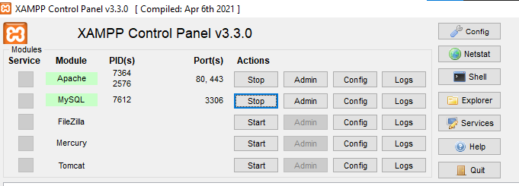
Figure 0-1:Installation of XAMPP

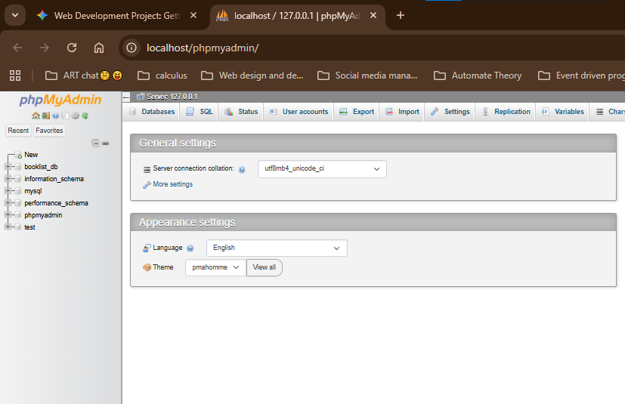
Figure 0-2: Apache and MySQL Running

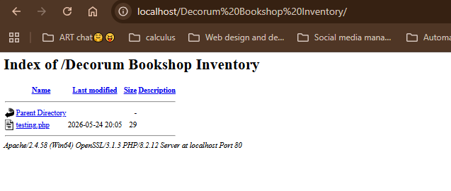
Figure 0-1:Localhost Test Page
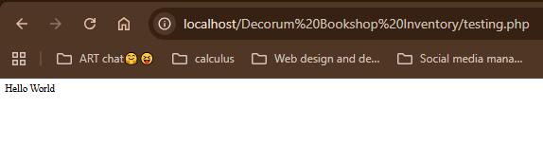
Figure 0-2: Hello World Test

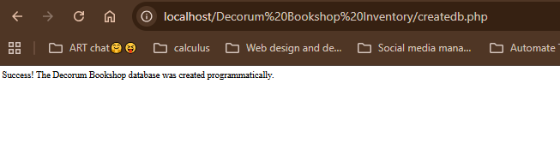
Figure 0-3: Database Connection Test

Error experienced during connection test. The webpage is not connected to the database. The PDO point sout the exact cause of the error.
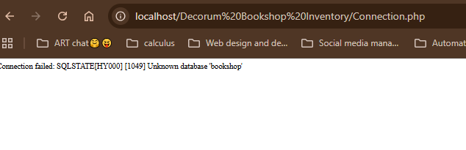
Figure 0-4: Error experienced during connection test.

REFLECTION
Fig 0-2 shows the MySQL can run on the computer as the local host. Fig 0-4 shows connection of the database to PHP sing PDO(PHP for Data Objects). PDO allows change of databases with minimal code change, meaning I can change to PostgresSQL or any other easily as compared to using mysqli-connect. This is more rigid as it serves MySQL and change would require changing the entire code. Using
$conn->setAttribute(PDO::ATTR_ERRMODE, PDO::ERRMODE_EXCEPTION);
prompts PDO to point out the exact case of error if the try block fails as seen in Fig 0-4
I’ve also learnt that a database can be created via PHP (Code below). The output is as seen in Fg0-3s
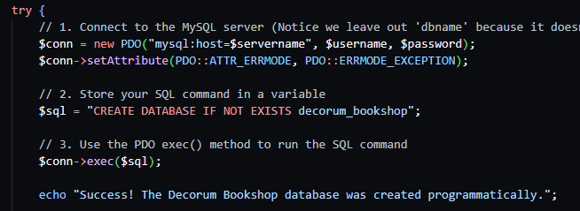
pFigure 0-5:PHP script for creating decorum_bookshop

Week 2: Wireframes and GUI Design

Title: User Interface Planning and System Design
- Hand-drawn Wireframe
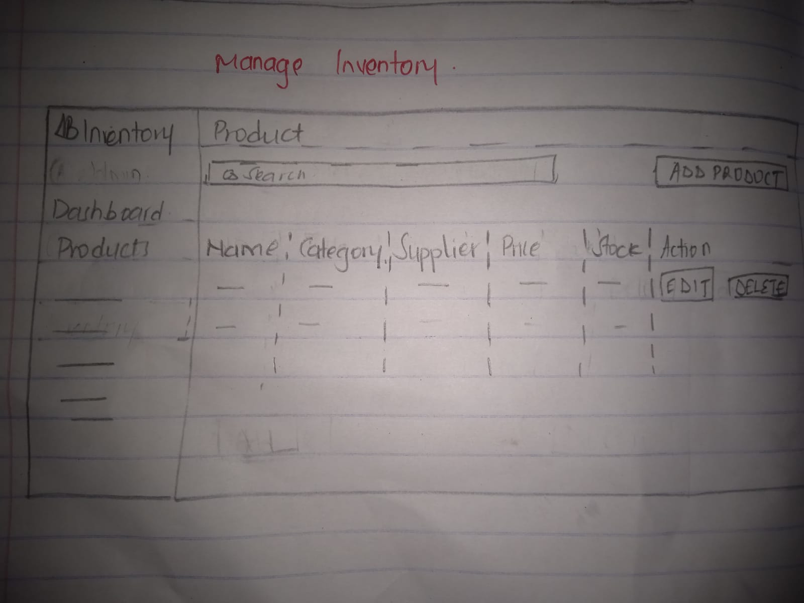
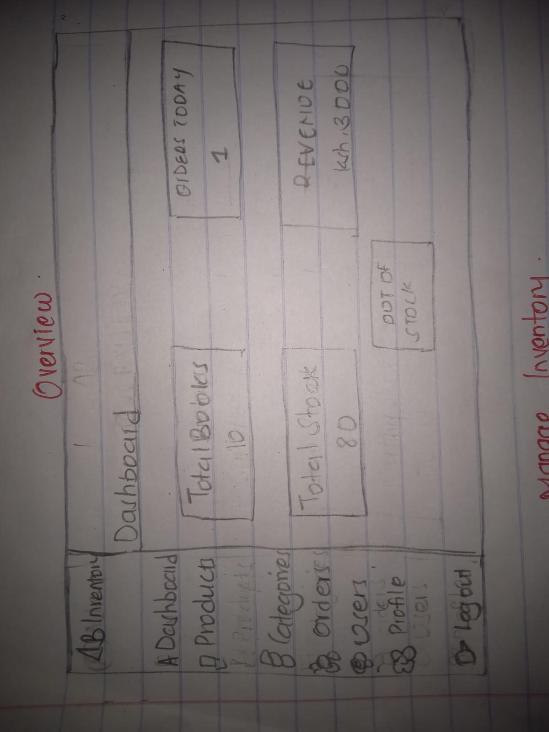Figure 0-1: Admin Product View
Admin Dashboard

Fig 2: Dashboard Layout Design
Figure 0-2:Admin Dashboard

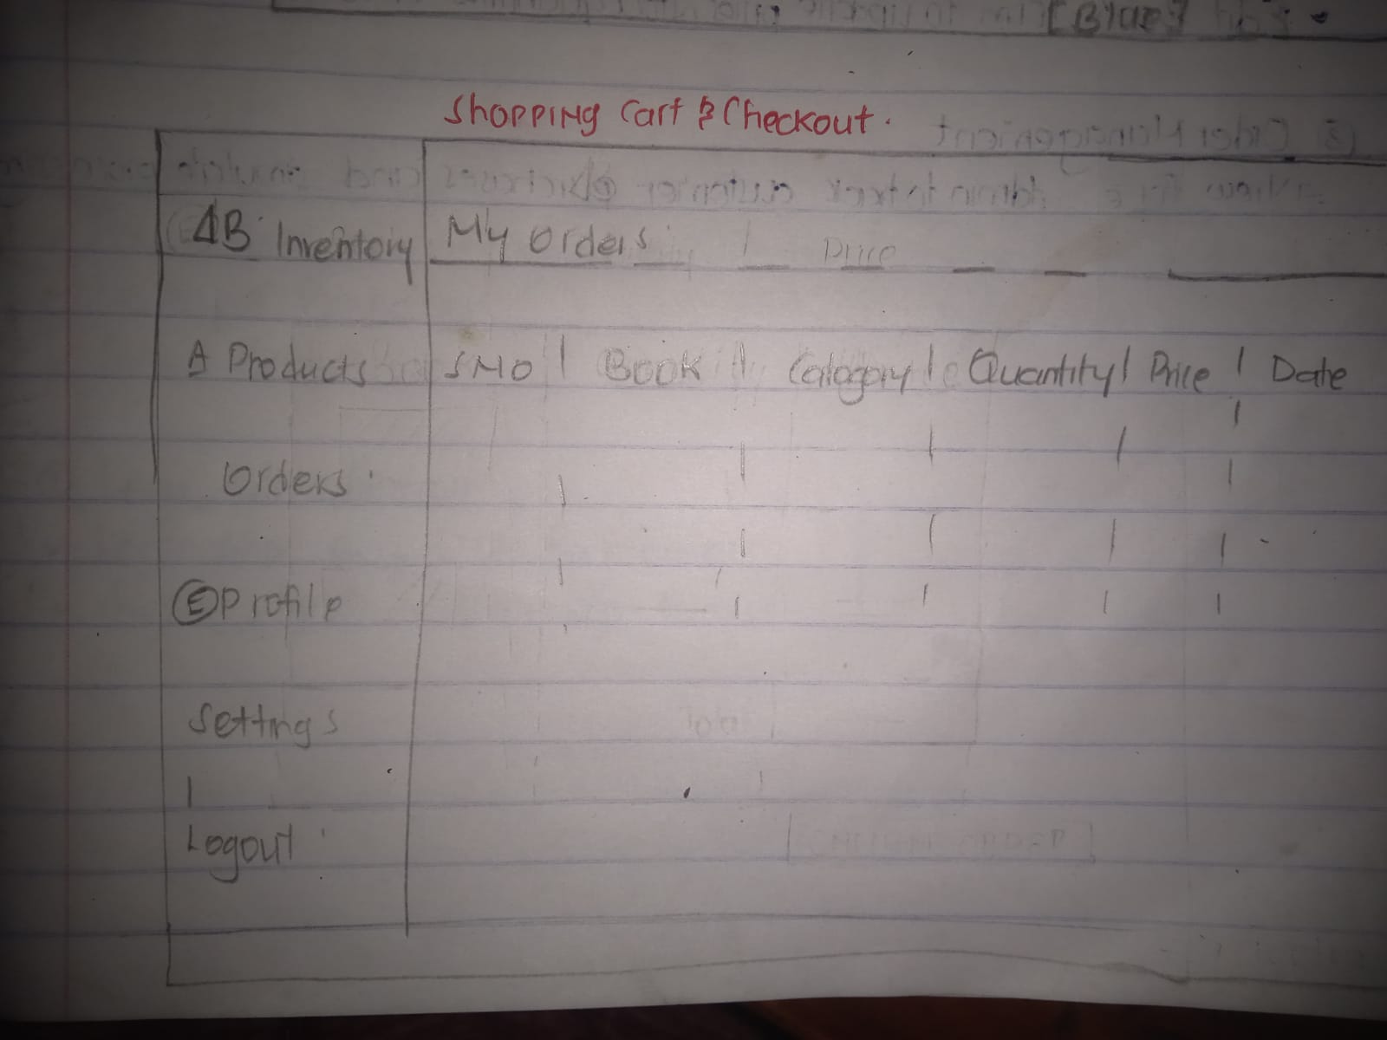
Figure 0-3:Users Order View
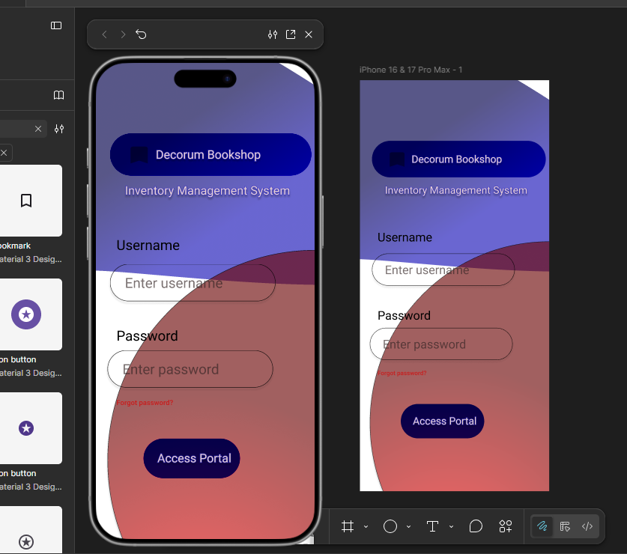
Figure 0-4:Login Page Design process
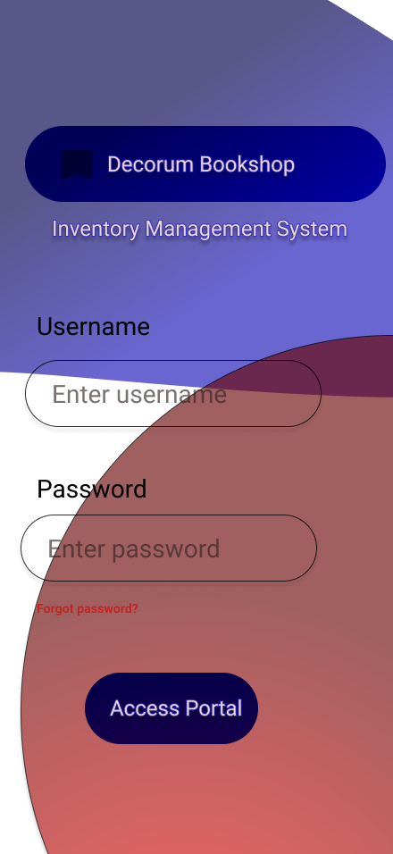
Figure 0-5:Login Page Figma Design
- COLOR THEME
- Red
- Blue
- White
- PROJECT THEME
Inventory System – Decorum Bookshop Inventory System.
Allows Admin manager to keep track of the books and records. The admin admits and tracks users within the system.
It is a Buyer to Buyer system (B2B)

REFLECTION
Creating the UI/UX components was challenging. I was able to hand draw but was challenged using Figma . Used a sidebar on the left because it is easy to hide and provide a simple, easy too. Use of Red, Blue and White color for their simplicity and easy communication. The dashboard itself remains static as content on it changes depending who has logged in(Admin/Manager). I’ve experienced multiple errors while translating the Figma design to code,currently working with a mockup.

Week 3: JavaScript and PHP Basics

Title:Frontend Interaction and Backend Foundation

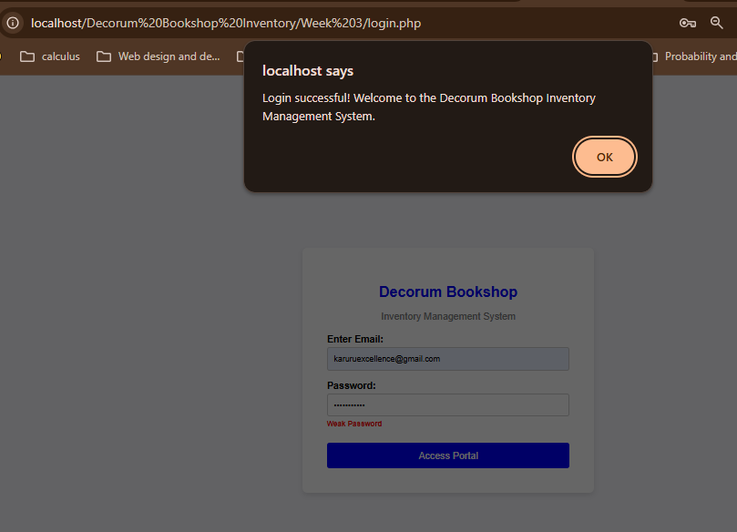
Figure 0-1:JavaScript Form Validation
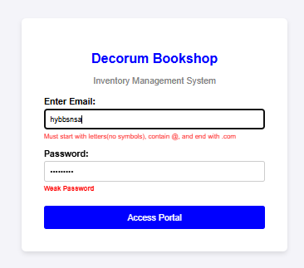

Figure 0-2:Email & Password validation.
Email Validation. Invalid email evokes an error message that prompts the user to enter the correct email format.

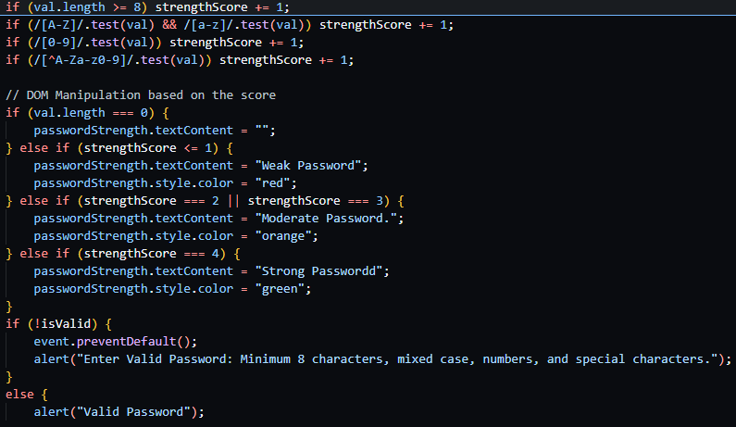
Figure 0-3:Password checker code

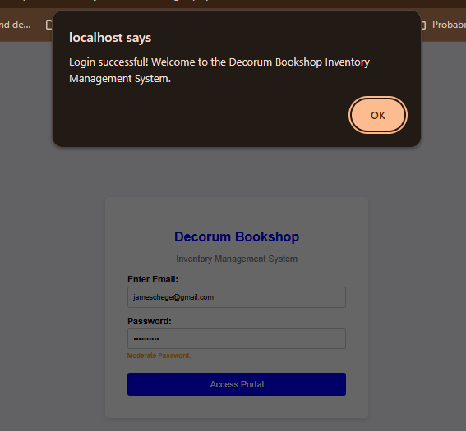
Figure 0-4:Successful login

Once user enters a Valid email & Password, they receive a SUCCESSFUL LOGIN message.
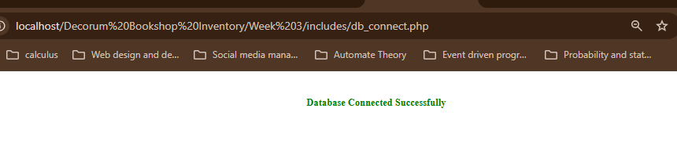
Figure 0-5:Successful Database Connection

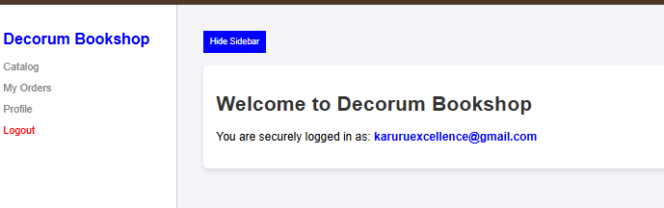
Figure 0-6: Successful login Into Decorum Bookshop
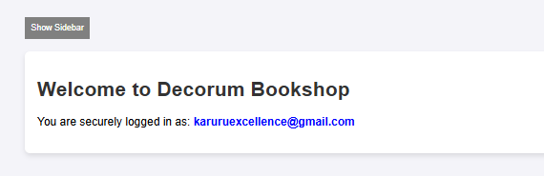
Figure 0-7: Hidden Sidebar
Document Object Model (DOM) is Achieved via Interactive Show/Hide Sidebar Button. It either Hides the sidebar when clicked and vice versa.

REFLECTION
Used PDO PHP with javascript and HTML. Implemented Password & Email validation using Java script. Learnt about Document Object Model and how to implement it. The Show/Hide SideBar Button changes the content of the page dynamically. Pushed the entire week 3 on Github for version Control and tracking changes.Encountered a few issues while committing Week 3 work but it was resolved. Commiting changes on

Week 4 Lesson: Server-Side Components and Backend Development Foundations

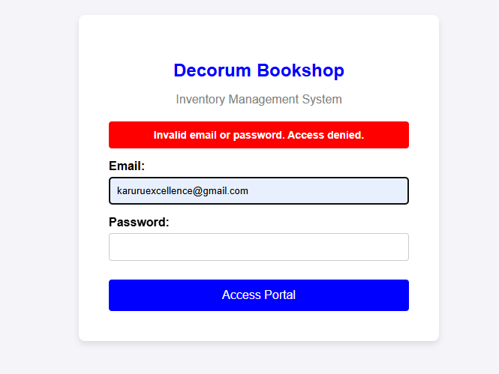
Figure 0-1:Server-Side authentication Handling
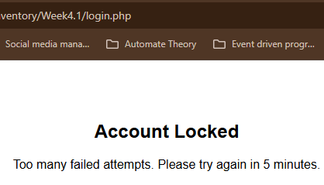
Figure 0-2:Account Bloced after 5 failed attempts
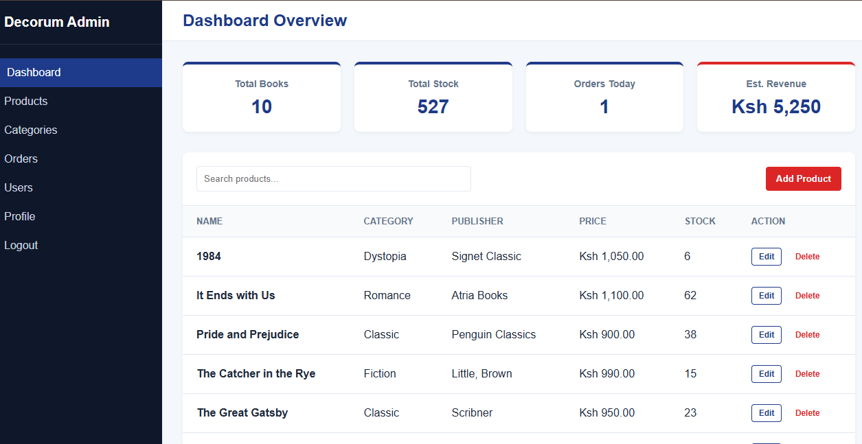
Figure 0-3RBAC- Administrator Dashboard
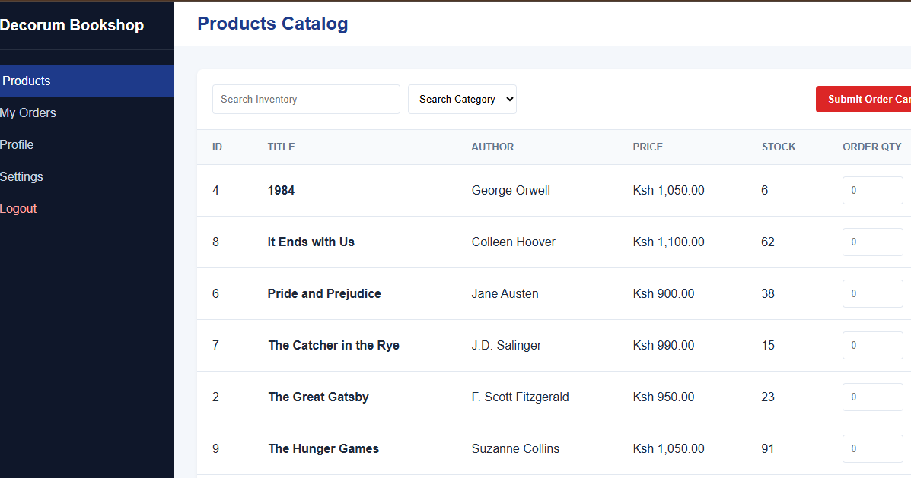
Figure 0-4: The Managers view.

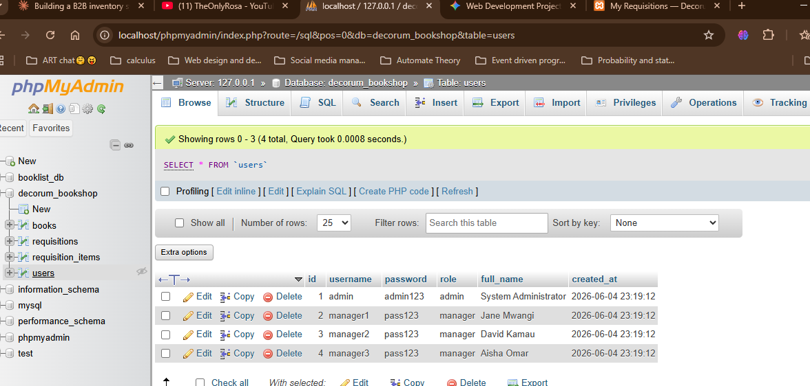
Figure 0-5: Backened Database schema- Users Table
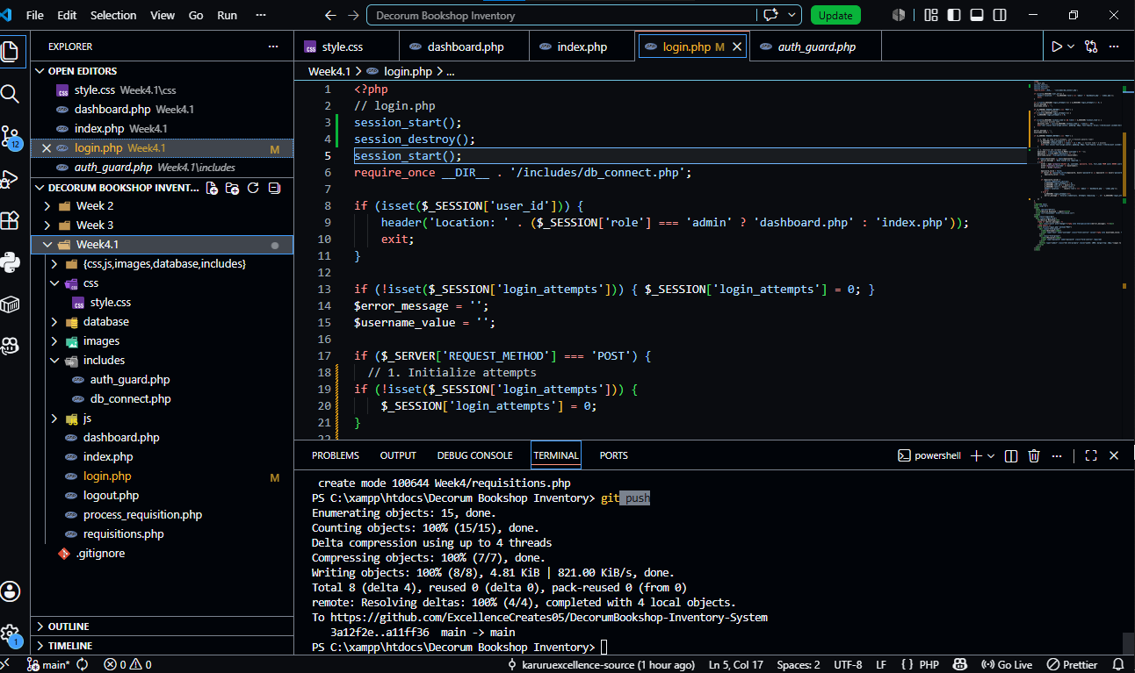
Figure 0-6: Backend Folder Structure

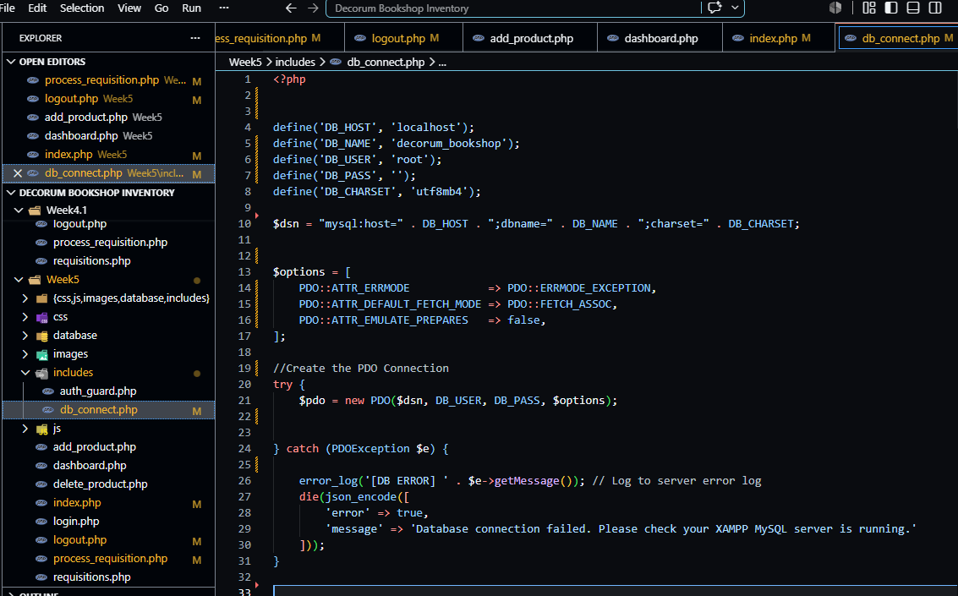
Figure 0-7: Dtabase Connection Script

REFLECTION

In this week I gained more knowledge on PHP for Data Objects centered Queries and code. It made it easy to work with clean prepared statements, making the platform more secure with less effort . I’ve learnt that it is Database agnostic , yet to prove but may test the feature in the future. Worked with a try-catch block in db_connect.php to connect to the database. It is well suited to handle exceptions that If…Else statement.

WEEK 5

TOPIC: Database Components and CRUD Operations

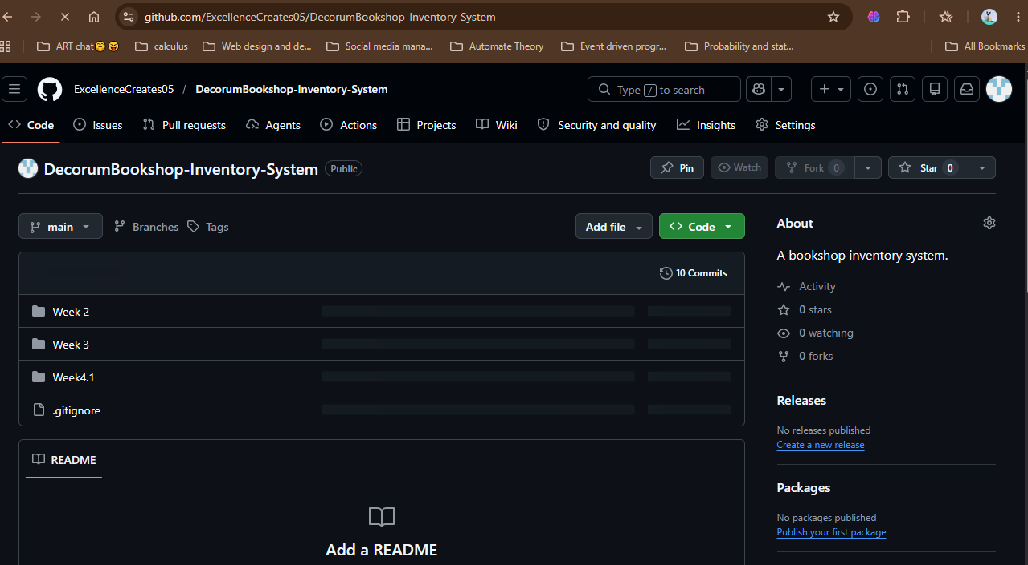
Figure 0-1:GitHub repository
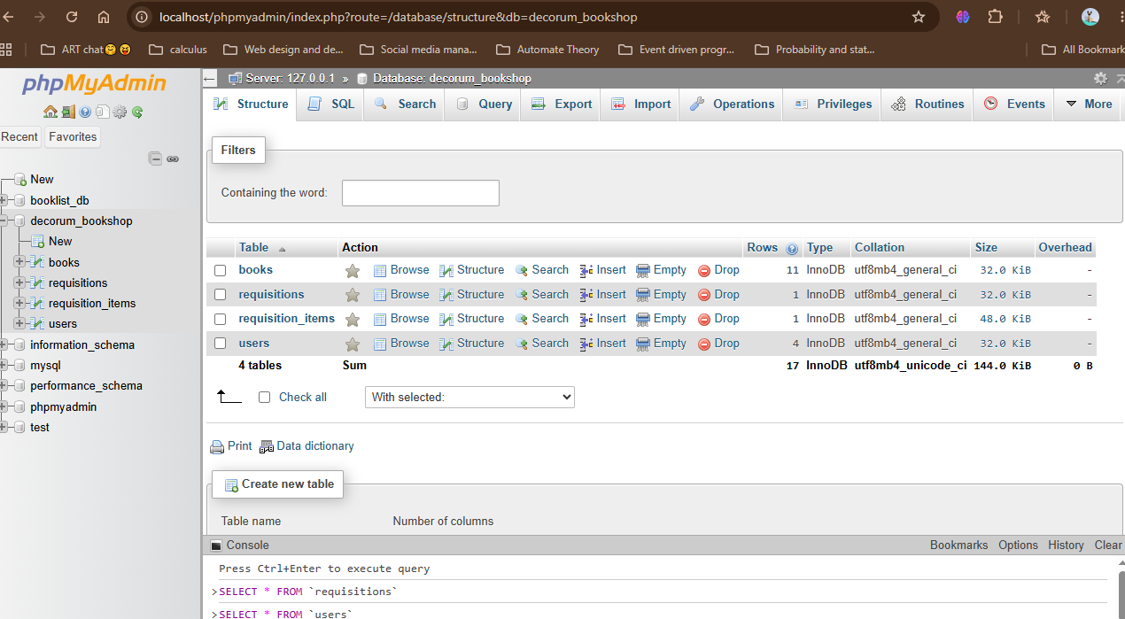
Figure 0-2: decorum_bookshop databse structure
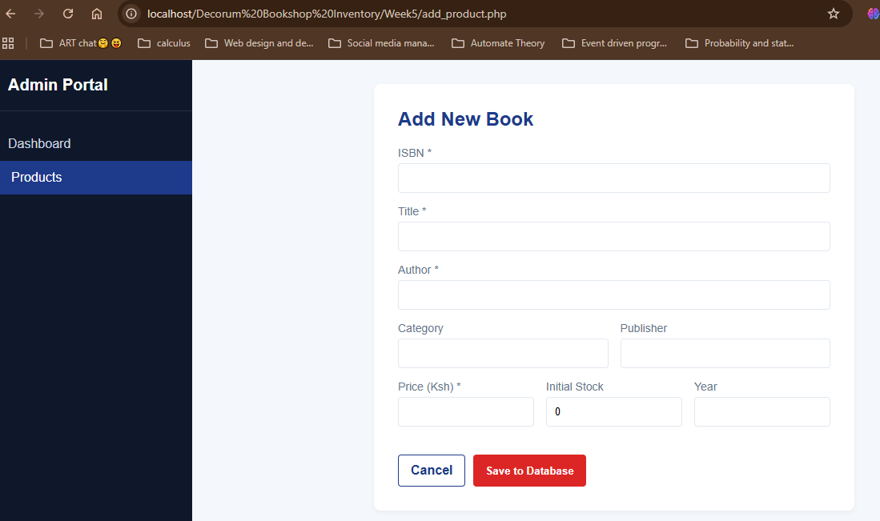
Figure 0-3: AddNew Book Form

Figure 0-4: New Book Added to the Catalog
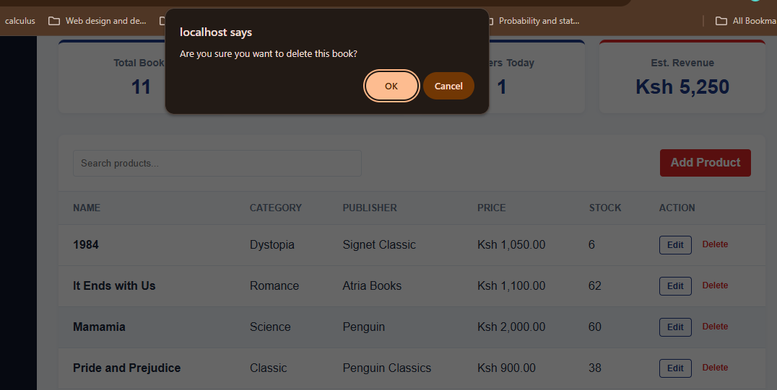
Figure 0-5: Delete A book From Database
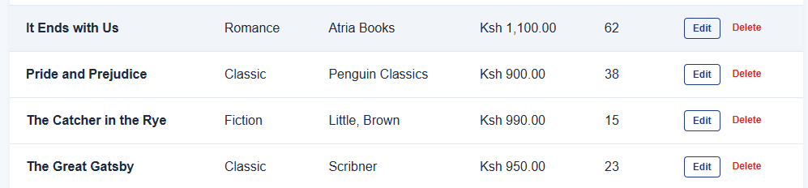
Figure 0-6: Deleted Record: Mamamia Book
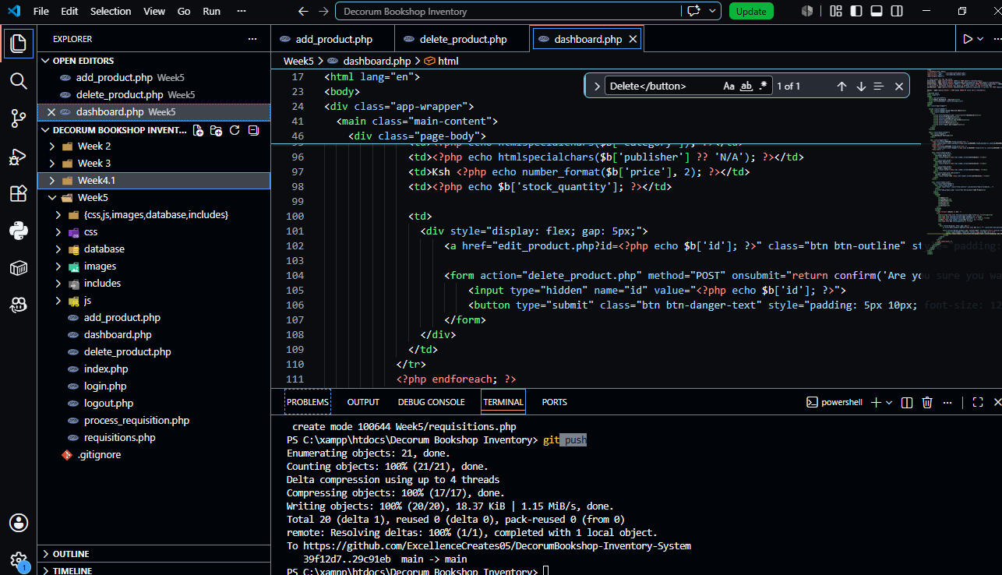
Figure 0-7: Week 5 File structure
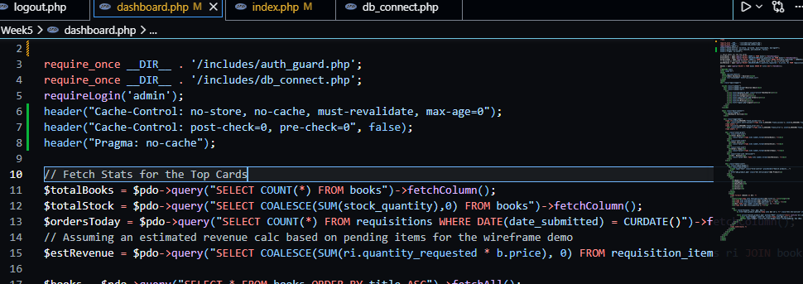
Figure 0-8:PDO Queries to fetch Order Mnagement Informtion from Database

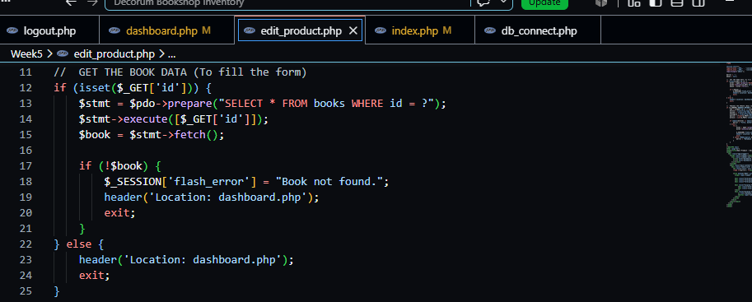
Figure 0-9: Fetch Block in edit_product.php to edit Record in Admin Dashboard
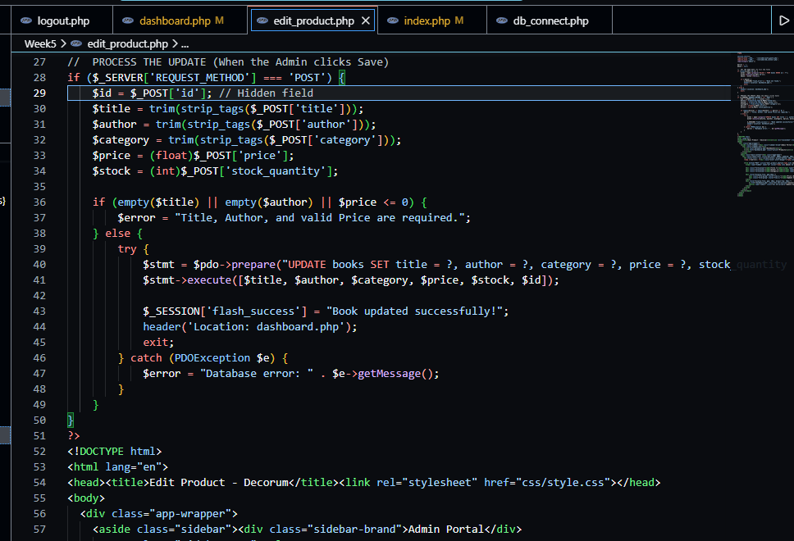
Figure 0-10: Catch block for edit button on Admin Dashboard

REFLECTION
Used pdo queries to communicate with the database. Fig 0_9 and Fig 0_10 show the fetch catch block (respectfully). The fetch block fetches this information from decorum_bookshop database enabling the Admin to edit the records in the edit book form, The Catch block processes the new records and ensures it reflects in the database and Products List . The PDO query (line 40-45; Fig_10), updates the records in the Database .

WEEK 6

Database Integration and CRUD Operations

